A window into your future activity
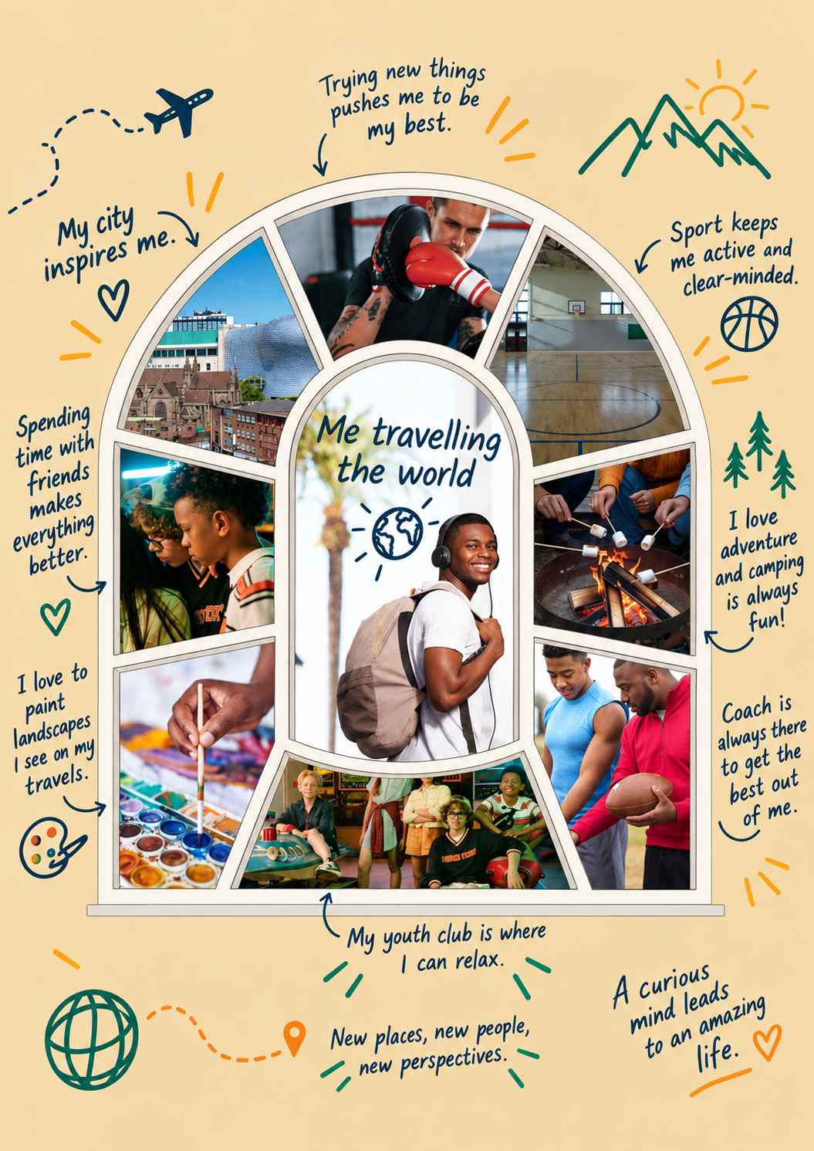
See template here.
If you could look through a window into your future, what would you see?
Imagine yourself achieving a goal, following a passion, making a difference or becoming the person you hope to be. Place an image representing that in the centre of the window.
Then fill the surrounding panes with the people, places and experiences that are helping you get there right now – the youth workers who believe in you, the spaces where you belong, the activities that build your confidence and the opportunities that help you grow.
You could use photos, drawing, words or symbols that represent the relationships, spaces and opportunities shaping your journey.
Together, they tell the story of where your future begins.
Activity Guide
About the Activity
This reflective and creative activity invites young people to imagine their future and explore the people, places and experiences helping them get there.
Using a window template, young people create a visual representation of their future aspirations. The centre of the window represents the future they hope to achieve, while the surrounding panes capture the relationships, spaces and opportunities that are helping to shape that journey today.
The activity encourages reflection, conversation and recognition of the positive role youth work plays in helping young people grow, belong and thrive.
Learning Outcomes
Young people will:
- Explore their hopes, ambitions and aspirations.
- Reflect on the people who support and encourage them.
- Recognise the places where they feel safe, valued and connected.
- Identify activities and experiences that help them develop skills and confidence.
- Understand how their future is being shaped by the opportunities available to them today.
What You’ll Need
- Window template (printed or digital)
- Pens, pencils and colouring materials
- Magazines for collage (optional)
- Printed photographs (optional)
- Sticky notes or labels
- Scissors and glue (if creating a collage)

Introducing the Activity
Explain to the group:
“The Youth Work Week theme this year is ‘Where Futures Begin’. Every future starts somewhere. The people we meet, the places we spend time and the experiences we have all help shape who we become.
Today we’re going to create a window into your future. In the centre, you’ll show something you hope for in the future. Around it, you’ll capture the people, places and experiences that are helping you get there.”
Step 1: Imagine Your Future
Invite young people to think about:
- What would you like your future to look like?
- What are your hopes, dreams or ambitions?
- What kind of person do you want to become?
- What would make you proud of yourself?
Ask them to place an image, drawing, photograph, symbol or written statement in the centre of the window.
Step 2: Look Around You
Ask young people to fill the surrounding panes with the things that are helping them move towards that future.
Encourage them to think about:
People
- Who believes in you?
- Who encourages you?
- Who helps you when things are difficult?
- Who inspires you?
Places
- Where do you feel safe?
- Where do you belong?
- Where can you be yourself?
- Where do you learn and grow?
Activities and Experiences
- What helps you build confidence?
- What do you enjoy doing?
- What skills are you developing?
- What opportunities have helped you discover your strengths?

Step 3: Share the Story
Invite participants to share their window with the group, a partner or a youth worker.
Useful prompts:
- Tell us about the future you’ve chosen.
- Which pane is most important to you?
- What support has helped you most?
- What role has youth work played in your journey?
- What is one thing you want to do next to move closer to your goal?
Reflection
Finish by reminding young people:
“Your future doesn’t begin somewhere else, someday. It begins here, with the people, places and opportunities that help you grow every day.”
Displaying the Windows
Completed windows can be:
- Displayed in youth centres and community spaces.
- Shared during Youth Work Week events.
- Used as part of exhibitions celebrating young people’s achievements.
- Photographed and shared on social media (with appropriate permissions).
- Combined to create a collective “Where Futures Begin” gallery wall.
Campaign Connection
This activity supports the Youth Work Week theme:
Where Futures Begin – Celebrating the people and places where young people grow, belong and thrive.
Each completed window tells a unique story of aspiration, support and possibility, while highlighting the vital role that youth workers, youth spaces and community opportunities play in helping young people build their futures.
Share your window!
Take a photo of your finished piece and share it during Youth Work Week, 2 - 8 November 2026, using #YouthWorkWeek2026 #WhereFuturesBegin
Think about how you could collectively display them and whether you can showcase it as part of a wider Youth Work Week event.

