YWW 2026 Where Futures Begin – Window Display Workshop
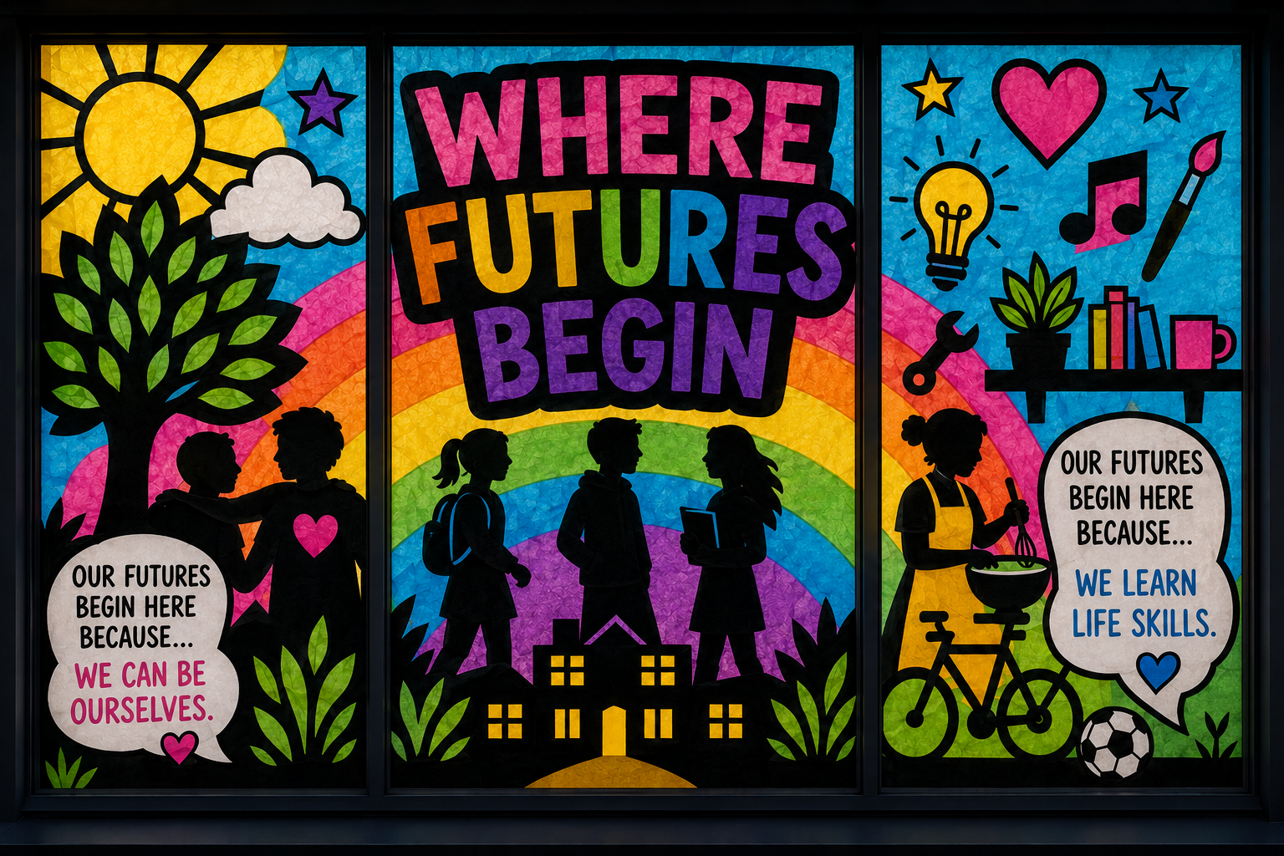
Session length: 2 hours
Design: 1 hour
Installation: 1 hour
Age: Suitable for youth groups of different ages and abilities
The idea
Create a colourful window display inspired by Youth Work Week 2026: Where Futures Begin – Celebrating the people and places where young people grow, belong and thrive.
Your window should show what helps young people grow, belong and thrive – this could be your youth club, the people in it, the things you do together, your community, or the hopes and opportunities you have for the future.
You’ll use colourful tissue paper, thick black paper and provided templates to create a bold, eye-catching design. You can also use temporary window paint or pens if preferred.

Templates
We’ve created a handy pack of templates to help you design your window display – but don’t be limited by these and feel free to add your own ideas.
1. Get inspired – 10 minutes
Introduce the Where Futures Begin theme.
Ask the group:
- What makes our youth club a place where futures begin?
- What helps young people feel like they belong?
- Who helps us grow or try new things?
- What opportunities or experiences do you enjoy?
- What does a positive future look like to you?
Collaborate: Together, choose one or two ideas you want your window to communicate (or more if you have a really big window and lots of people to help fill it!)
Optional prompt for young people:
“Our future begins here because…”
This could also make a great sentence to include somewhere in the window!
2. Plan your window – 10 minutes
As a group, decide what your display will look like.
Think about:
- Words or messages you want to include
- Images or symbols that represent your ideas
- Where different elements will go in the window
- How you can make the design visible and colourful from outside
Tip: Keep shapes and lettering bold and simple so they can be seen clearly through the window.
3. Create! – 40 minutes (or longer depending on session length)
Use the provided templates to cut out shapes and lettering.
Materials:
- Colourful tissue paper
- Thick black paper/card
- Templates
- Scissors
- Glue/tape
- Temporary window paint or pens (optional)
Experiment with layering tissue paper, creating black outlines and combining different shapes and colours.
Remember: 'There doesn’t need to be one ‘right’ design – young people can make it their own!'
4. Put up your display – 60 minutes
Once the design is finished, it’s time to transform your window!
Work together to:
- Clean/dry the inside of the window if needed.
- Decide where each element should go.
- Attach the designs securely with tape or blu tack.
- Step outside and check how it looks from the street – it’ll look even better with the lights shining through it.
- Make any adjustments so the main message and colours are easy to see.
If you don’t have enough time: Don’t worry! The young people can complete the design during the session and leaders can put the window display up afterwards.
Share your window!
Take a photo of your finished display and share it during Youth Work Week, 2 - 8 November 2026, using #YouthWorkWeek2026 #WhereFuturesBegin
Think about who you could invite to look at your window and whether you can showcase it as part of a wider Youth Work Week event.

