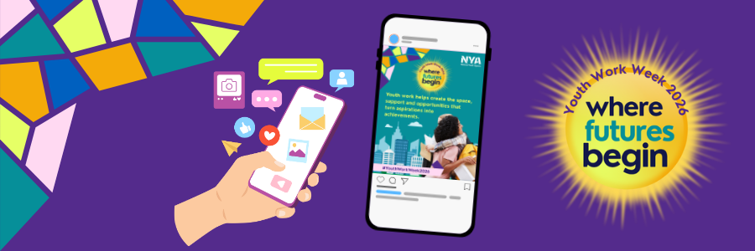
Youth Work Week 2026: Young People's Social Media Toolkit
Youth Work Week 2026 takes place from 2-8 November and this year's theme is Where Futures Begin.
The theme recognises that every young person's journey is shaped by the people who support them, the places where they feel they belong and the opportunities they're given.
Whether it's a youth worker who believed in you, a club that helped you build confidence, a friendship you made, or a goal you're working towards, Youth Work Week is an opportunity to celebrate the people and experiences helping shape your future.
There is no right or wrong way to take part. We encourage you to share your own experiences, aspirations and achievements in whatever way feels most authentic to you.
Don't forget to include #YWW2026 so we can see and share what you're doing during the week.

Social media post templates
Download the ready to use graphics here. More options are available

Graphics | Suggested captions
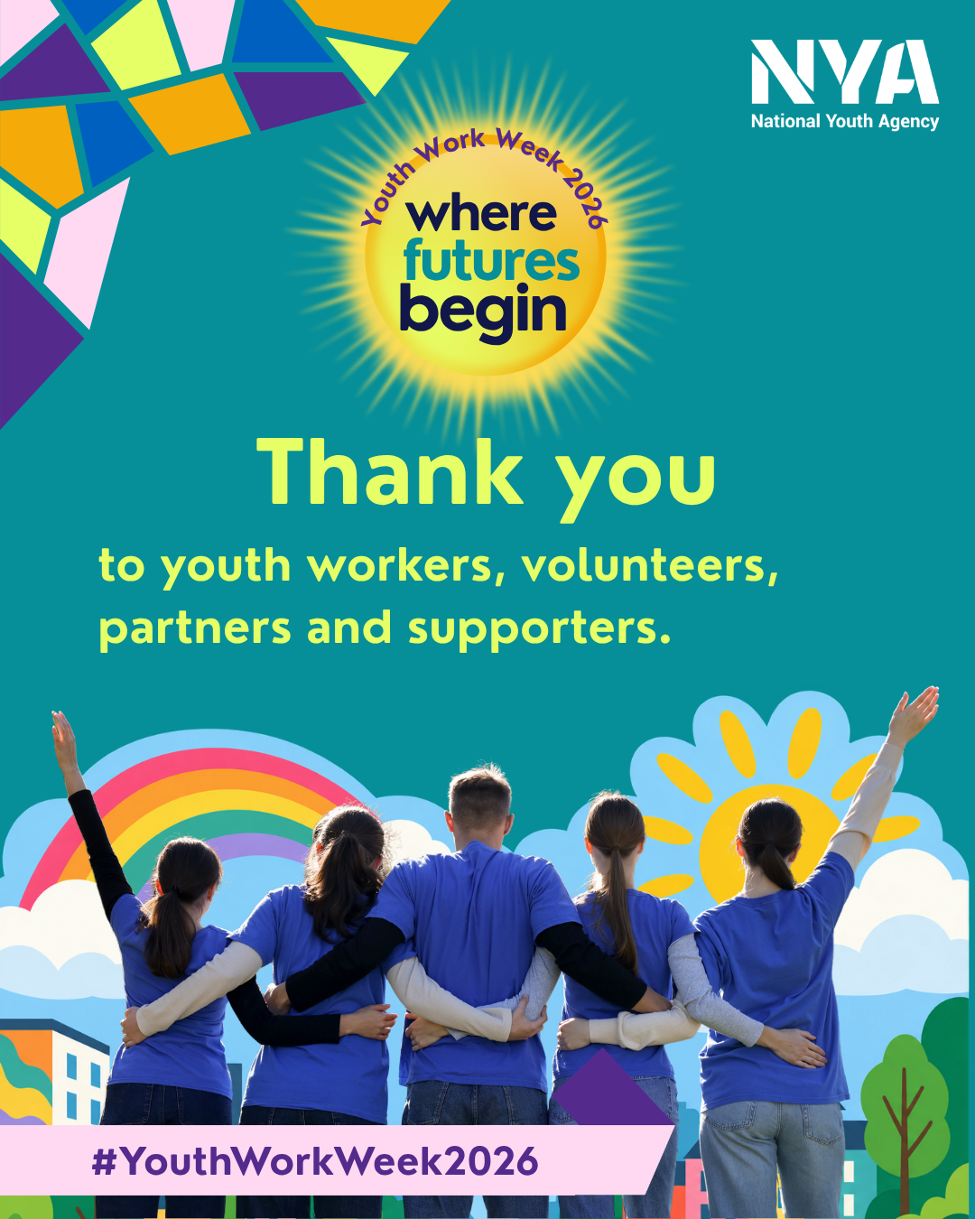 | This #YWW2026 I'm celebrating the people, opportunities and experiences that have helped shape my future.  Thank you to everyone who has supported me along the way.
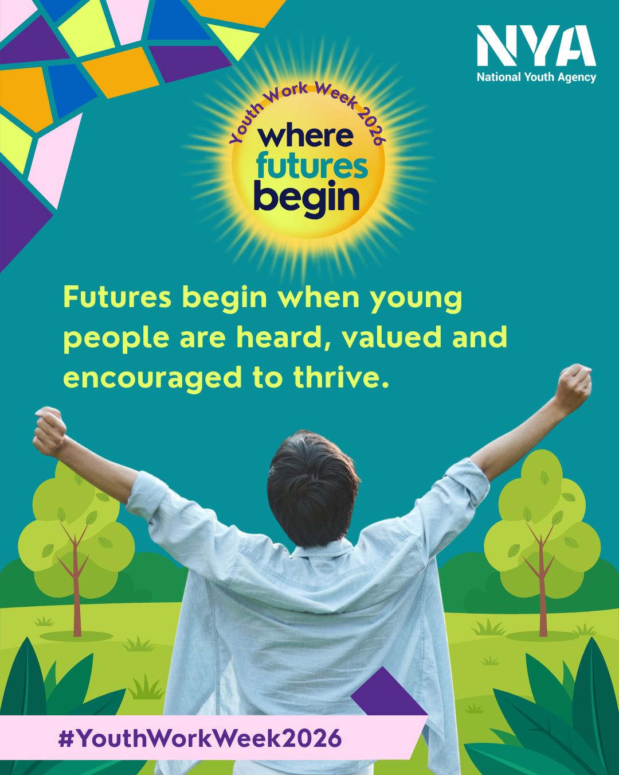  Rather than use a premade graphic, you could create your own using our Youth Voice templates detailed below.  Alternatively, you could illustrate or write your thoughts and experiences using your own handwriting, or record a voiceover explaining your response to these prompts. That personal touch can help people connect with your story and better appreciate the power of youth work. | A future I'm working towards is __________.  One thing helping me get there is __________.  #YWW2026  #WhereFuturesBegin

Youth Voice templates
Youth Voice Templates
We've created a range of graphics and story templates to help young people share their experiences and aspirations during Youth Work Week.
Use them to complete the following prompts:
- Youth work has helped me to...
- My future looks like...
- I couldn't have done it without...

Access the youth voice templates on Canva here.

