Youth Work Week 2026 campaign film session plan

Where Futures Begin: how do youth workers make a difference?
Age Range: 11-18 years, Duration: 60 minutes, Group Size: 8-30 young people
Youth Work Approach: Participative, reflective, strengths-based discussion
Resources needed:
- Campaign film: nya.org.uk/where-futures-begin
- Projector/screen
- Sticky notes (3 colours)
- Flipchart paper or large sheets
- Marker pens
- Printed image of gardening gloves (or actual gloves as a prop)

Session aim
This discussion-based session has been developed to accompany our Youth Work Week 2026 campaign film, ‘Where Futures Begin’, and explores the power of belonging, trusted relationships and the positive impact youth work can have on young people's lives.
The film aims to illustrate how youth work can be the catalyst for positive change in a young person’s life – by spotlighting the fictional story of a boy who is struggling to fit in with his peers and is disconnected from those around him, carrying the weight of the world on his shoulders. It was released by the NYA to spark conversations about different people’s experience of youth work and how it has helped shape their journey.
Using NYA’s short campaign film and a series of reflective activities, young people will consider what it means to feel included, how small welcoming gestures and non-judgemental support from a youth worker, can make a lasting difference. They will also be encouraged to think about how the opportunity to try new things and make new friends helps foster new interests and build self-confidence which will help them as they move towards adulthood.

Outcomes
By the end of the session, young people will:
- Reflect on the emotions and experiences shown in the film.
- Recognise how small acts of kindness and inclusion can make a significant difference.
- Understand some of the ways youth workers support young people.
- Identify people, places and activities that help them feel connected and valued.
- Consider how they can support others who may feel isolated or excluded.

1. Welcome and warm-up

"Step Into the Story" (10 minutes)
Place signs around the room:
- Strongly agree
- Agree
- Not sure
- Disagree
Read out the following statements and invite young people to move to the position that best reflects their view:
- It's easy to tell how someone is feeling by looking at them.
- One conversation can change someone's life.
- Asking for help is difficult.
- Feeling part of a group is important.
- Small acts of kindness matter.
After each statement, ask 1-2 volunteers to share their thoughts.
Facilitator note: Avoid right or wrong answers. Encourage different perspectives and create a safe, respectful environment.

2. First reactions

First viewing (5 minutes)
Ask young people to simply watch and notice:
"What stood out to you?"
"How did the film make you feel?"
Show the film.
Immediately afterwards, ask for quick one-word reactions – they can write these on sticky notes to be added to the flipchart.
Examples might include:
- Lonely
- Hopeful
- Nervous
- Sad
- Relieved
- Encouraged
- Embarrassed
- Amused

3. Feelings detective

Exploring the emotional journey (15 minutes)
Draw a large line across flipchart paper representing each scene in the story.
Label sections:
- Beginning
- Nearby
- Guidance
- Opportunity
- Opportunity #2
- Engagement
- Montage
- Returning
- Flashforwards
Split into small groups.
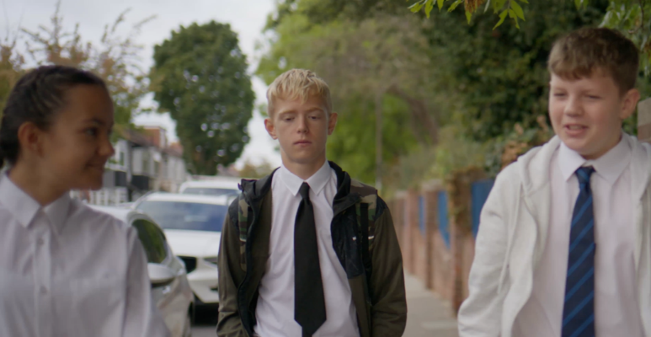 | Section 1:  Beginning  Young person’s starting point, at their lowest.
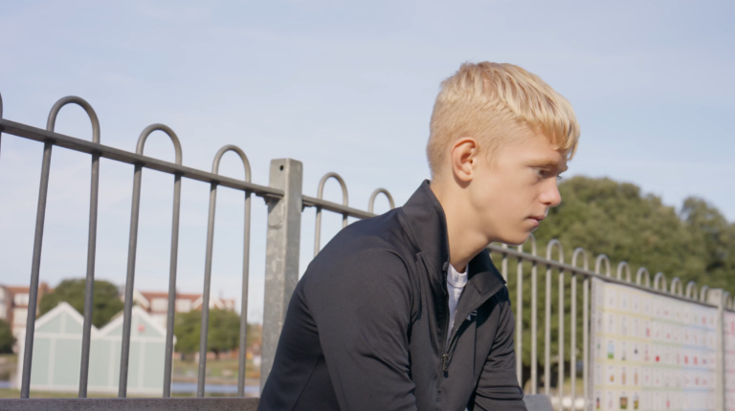 | Section 2:  Nearby  Zach is in the same space as the youth project, overhears what activity they have planned, still not engaged.
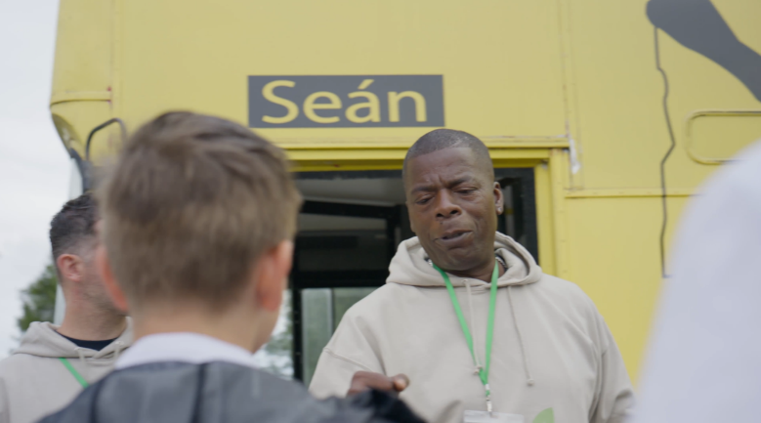 | Section 3:  Guidance  Close-by the youth worker engage Zach’s friends, speaks to them about their future plans.
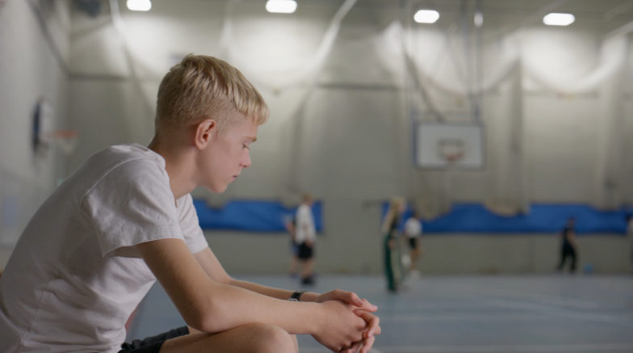 | Section 4:  Opportunity  Young people directly invite Zach to join them, but he doesn’t feel able to.
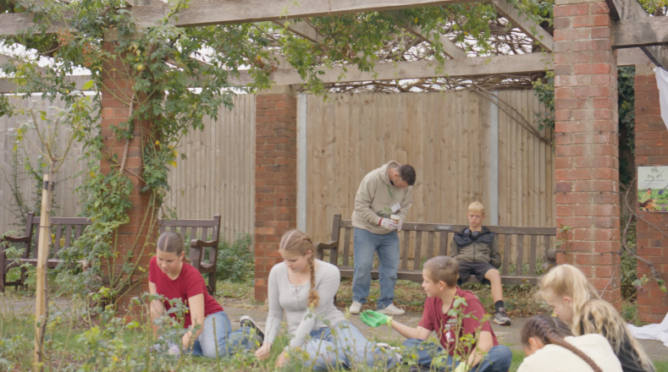 | Section 5:  Opportunity #2  Paul spots Zach nearby as they do their allotment activity, repeats the low pressure invitation, jokes about his gardening gloves.
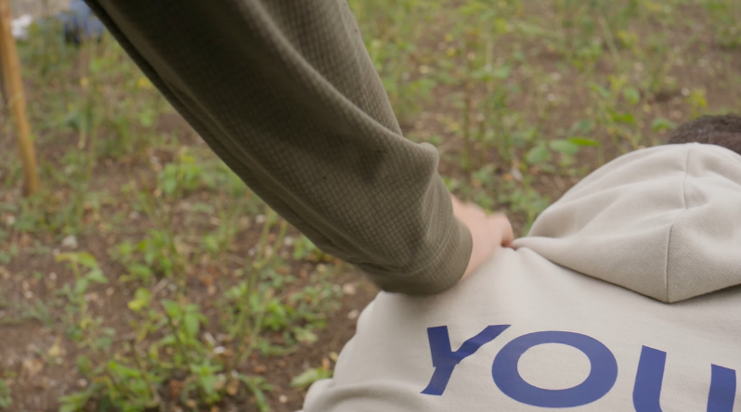 | Section 6:  Engagement  Zach finally chooses to join the group, takes part in the activity.
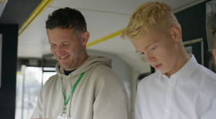 | Section 7:  Montage  A succession of shots showing Zach growing in confidence as he continually engages in activities with the youth project.
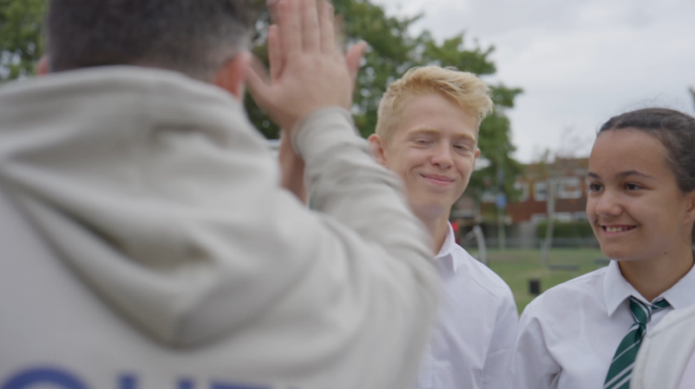 | Section 8:  Returning  A parallel of an earlier shot outside the bus, this time Zach is fully integrated into the group.
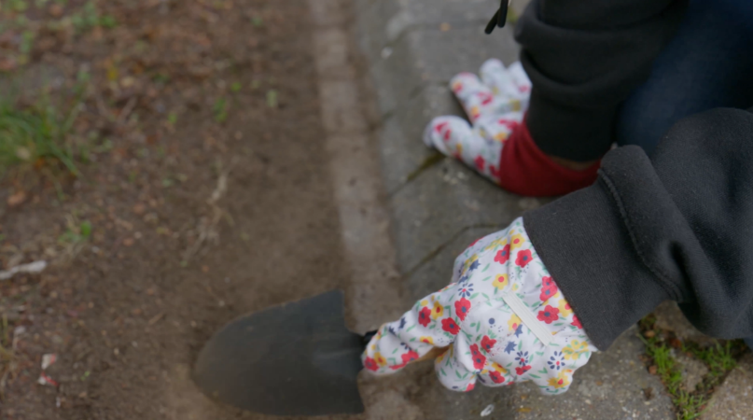 | Section 9:  Flashforward  Zach, older now, leaves college with a group of friends, he spots a gardener with gloves similar to the ones he used to wear at the youth project, he remembers it and smiles as he is ready to continue into his future.
Give each group sticky notes and ask them to identify:

What might the young person be feeling and thinking?
Examples:
Section 1: Beginning
Young person's starting point, at their lowest
Feeling:
- Isolated
- Directionless
- Bored
- Frustrated
- Lacking confidence
- Unseen or forgotten
Internal thoughts:
- "What's the point?"
- "Nothing ever changes."
- "Nobody really notices me."
- "Everyone else seems to have somewhere to be."
Section 2: Nearby
Hears activity taking place but remains disengaged
Feeling:
- Curious but guarded
- Sceptical
- Detached
- Wary of getting involved
Internal thoughts:
- "It sounds alright, but it's not really for me."
- "I'd probably just feel awkward."
- "They're all already part of it."
Section 3: Guidance
Watches youth workers engage his friends
Feeling:
- Interested
- Slightly hopeful
- Envious of the attention they're receiving
- Unsure of his own future
Internal thoughts:
- "They seem to actually care what they think."
- "I wouldn't know what to say if they asked me."
- "Must be nice having a plan.
Section 4: Opportunity
Peers invite Zach to join
Feeling:
- Encouraged but anxious
- Self-conscious
- Nervous about rejection or failure
Internal thoughts:
- "What if I don't fit in?"
- "Maybe another time."
- "They're just being polite."
Section 5: Opportunity #2
Paul offers another low-pressure invitation
Feeling:
- More comfortable
- Seen and recognised
- Amused
- Less threatened
Internal thoughts:
- "He's not giving up on me."
- "Maybe it wouldn't be so bad."
- "At least they aren't putting pressure on me."
Section 6: Engagement
Zach chooses to join
Feeling:
- Tentatively optimistic
- Relieved
- Proud of himself
- Welcomed
Internal thoughts:
- "Okay... this isn't as awkward as I expected."
- "I can do this."
- "Maybe I should have come sooner."
Section 7: Montage
Growing through repeated participation
Feeling:
- Increasingly confident
- Valued
- Capable
- Connected
- Motivated
Internal thoughts:
- "I've got something to contribute."
- "People expect me to be here."
- "I'm getting good at this."
- "I belong."
Section 8: Returning
Now fully part of the group
Feeling:
- Comfortable
- Accepted
- Happy
- Secure in his friendships
Internal thoughts:
- "These are my people."
- "I'm glad I stuck with it."
- "Coming here is just part of who I am now."
Section 9: Flashforward
Reflecting from the future
Feeling:
- Grateful
- Proud
- Nostalgic
- Hopeful
- Ready for the next chapter
Internal thoughts:
- "That youth project had a lasting impact on me."
- "The people there believed in me before I believed in myself."
- "I wouldn't be where I am now without them."
- "I'm ready for whatever comes next."
Groups place their notes along the timeline.
This progression creates a clear emotional arc: isolated → curious → hesitant → welcomed → involved → confident → connected → hopeful, mirroring the transformational impact of youth work.

Discussion questions
- Which part of the film felt most powerful?
- When do you think the young person's story started to change?
- Was there one big moment that changed everything, or lots of small moments?
- Why do you think the youth worker didn't pressure him to join in?
- What other words or gestures by the youth workers showed that they were skilled at their jobs?
Draw out the message that youth work often happens through trust, patience and relationships built over time.

4. The gloves activity

Small Things, Big Impact (15 minutes)
Show the gloves (or image of the daisy/loud gloves).
Ask:
"Why do you think the gloves are important in the story?"
Discuss how the gloves represented:
- Being welcomed
- Belonging
- Kindness
- Being remembered
- Someone believing in you
Give each young person a sticky note.
Ask them to write:

"What small thing has made a positive difference to you?"
This could be:
- Someone listening
- Being invited somewhere
- A teacher or other trusted adult encouraging them
- A friend checking in
- A youth worker remembering their favourite hobby
Alternatively, they can write:

"What small thing could you do to help someone feel included?"
Create a "Small Things Matter" wall display.

5. Where Futures Begin

Reflection and discussion (10 minutes)
Place a large sheet in the centre with the title:

Where Futures Begin
Ask young people:

What helped the young person move from this...
- Walking alone
- Avoiding opportunities
- Feeling sad

...to this?
- Feeling included
- Joining in
- Looking forward to the future
Write responses around the title.
Expected ideas:
- Someone noticed him
- No pressure
- Consistent support
- A safe place to belong
- Positive relationships
- New experiences
- Confidence growing over time
Then ask:
"What places, people or activities help you feel like you belong?"
Invite voluntary sharing.

Closing reflection (5 minutes)
Ask everyone to complete one sentence:

"One thing I'm taking away from today is..."
or

"One thing youth work can do is..."
Finish with:
"This film isn't really about gardening or gloves. It's about what happens when someone notices you, welcomes you and keeps the door open. Sometimes the smallest invitation can help someone discover a future they couldn't see for themselves."

Optional Extension
If time allows or for a follow-up session, invite young people to create:
- Their own storyboard showing a positive turning point in someone's life.
- A campaign poster answering: "What does youth work mean to me?"
- A letter to their future self about the people who help them grow and thrive.

Key messages to reinforce
- You never know what someone else may be going through.
- Inclusion often starts with a simple opportunity.
- Positive relationships can have a lasting impact.
- Youth work creates spaces where young people can belong, grow and thrive.
- Futures don't change overnight, but small moments can start positive journeys.

